**Project Design Phase**

**Problem – Solution Fit Template**

|  |  |
| --- | --- |
| Date | 19 February 2026 |
| Team ID | LTVIP2026TMIDS66321 |
| Project Name | Cafeteria Menu Display |
| Maximum Marks | 2 Marks |

**Problem – Solution Fit :**

The **problem–solution fit** for the cafeteria menu display project lies in addressing the inefficiency of traditional menu boards, which are often static, outdated, and difficult to update in real time, leading to customer confusion, long queues, and increased workload for staff. The proposed **digital cafeteria menu display system** directly solves this problem by providing a dynamic, centralized platform where menu items, prices, availability, offers, and nutritional details can be updated instantly and displayed clearly on digital screens. This ensures accurate information, improves transparency, enhances customer decision-making, and reduces dependency on verbal communication.

**Purpose:**

• To provide real-time updates of menu items, prices, and availability.

• To reduce customer confusion caused by outdated or unclear menu information.

• To minimize waiting time and overcrowding at ordering counters.

• To reduce staff workload by eliminating repeated verbal explanations.

• To improve accuracy in displaying food items and pricing details.

• To enhance the overall customer experience through clear and attractive digital displays.

• To enable easy modification of menus during peak hours or special occasions.

**Template:**

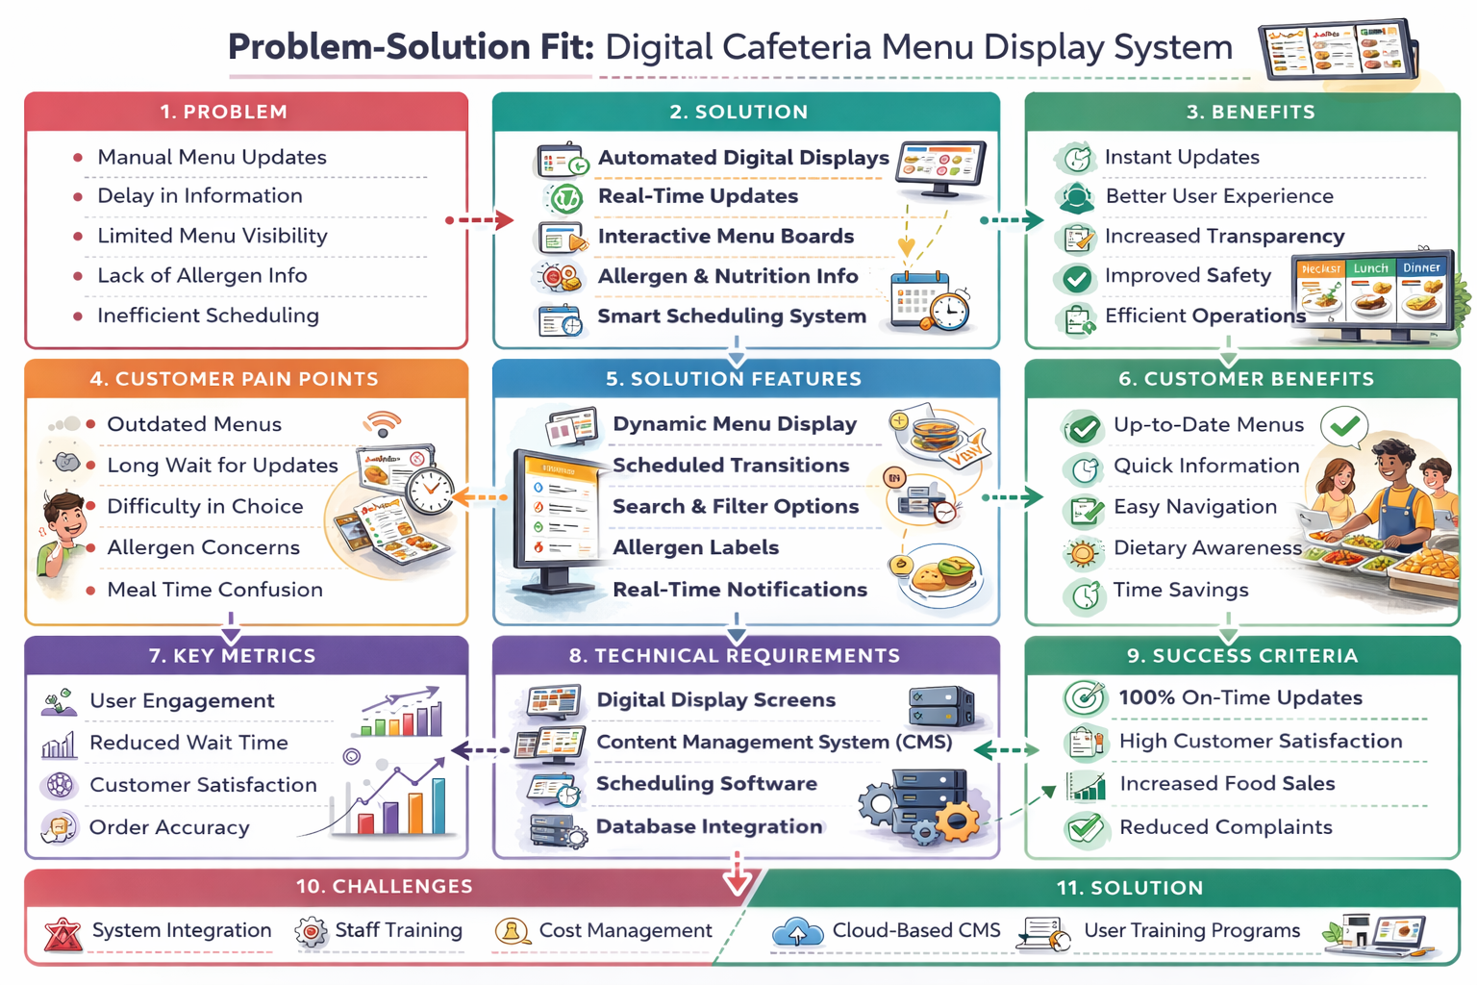

References:

1. <https://www.ideahackers.network/problem-solution-fit-canvas/>
2. <https://medium.com/@epicantus/problem-solution-fit-canvas-aa3dd59cb4fe>